ContactManagement_Verify Contact notes _Instance44_12-Jul-2018_03-43-44_AM_VerifyingAllNotesofanindividual.png

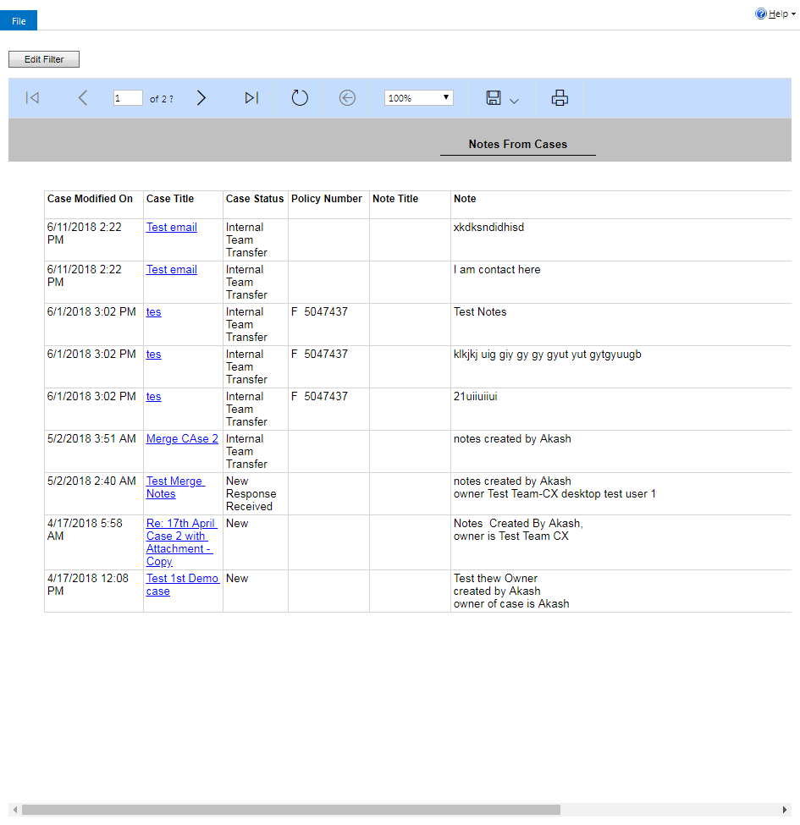

ContactManagement_Verify Contact notes _Instance44_12-Jul-2018_03-43-38_AM_Validatingcontactentitynavigation.png

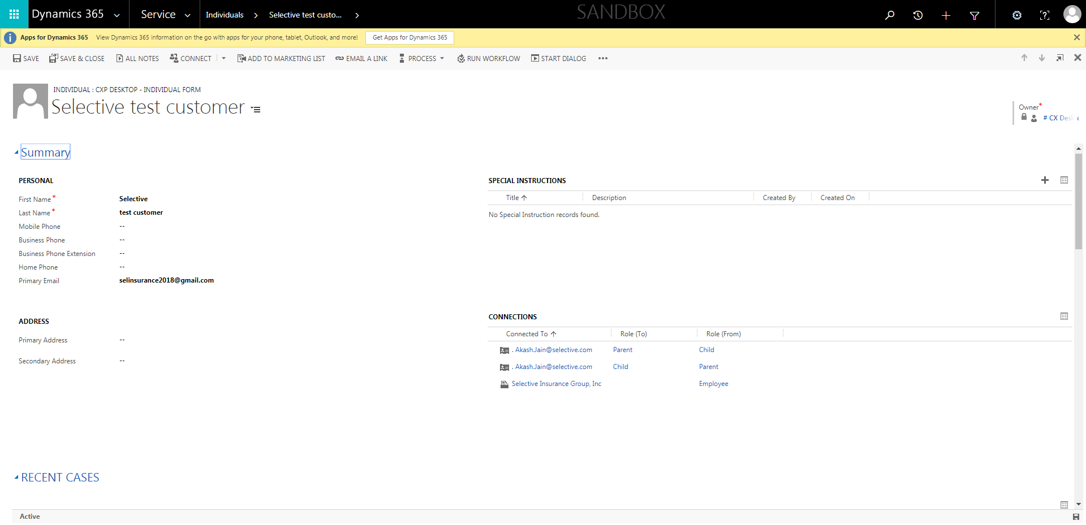

ContactManagement_Verify Contact notes _Instance44_12-Jul-2018_03-42-29_AM_SingleSignOn.png

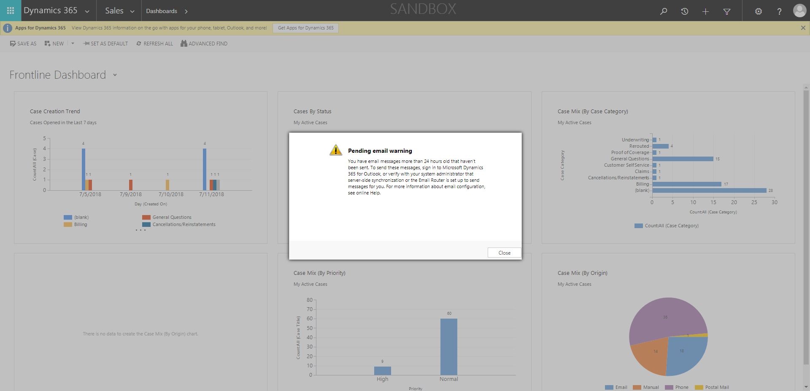

ContactManagement_Verify Contact notes _Instance44_12-Jul-2018_03-42-16_AM_MouseClickActiononStaleElement.png



ContactManagement_Verify Contact notes _Instance44_12-Jul-2018_03-42-19_AM_MouseClickActiononStaleElement.png

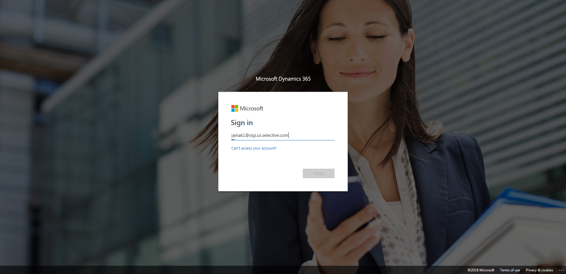

ContactManagement_Verify Contact notes _Instance44_12-Jul-2018_03-42-34_AM_SingleSignOn.png

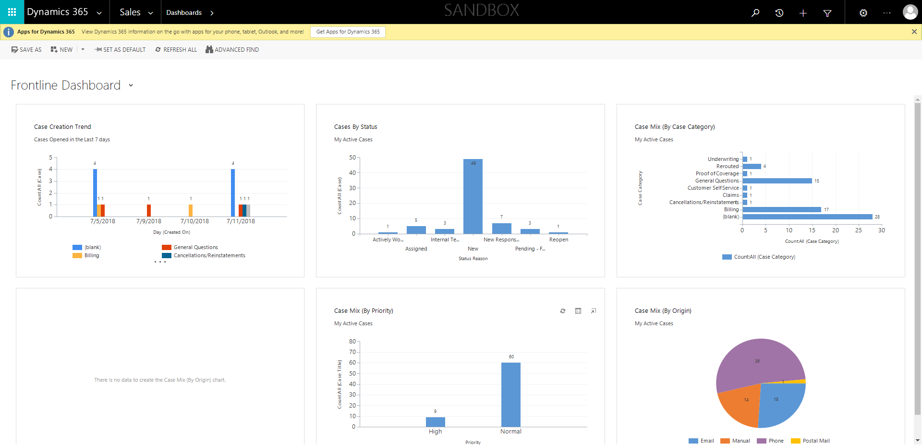

ContactManagement_Verify Contact notes _Instance44_12-Jul-2018_03-42-18_AM_EnterTextAction.png

